ANYTRON
any-cut
User Manual
Rev. 1.0 – 2015.02.
PUBLIC


Revision History
Rev | Date | Description | Editor
1.0 | 20140408 | Initial release
1.1 | 20150217 |  | Byung Yong Kang

[Table of Contents]
I. Introduction to and Installation of the System 오류! 책갈피가 정의되어 있지 않습니다.
1. Introduction to Acy-Cut 오류! 책갈피가 정의되어 있지 않습니다.
1.1 Introduction to Equipment 오류! 책갈피가 정의되어 있지 않습니다.
1.2 Installation Standard 오류! 책갈피가 정의되어 있지 않습니다.
1.3 Structure Installation 오류! 책갈피가 정의되어 있지 않습니다.
2. Safety 오류! 책갈피가 정의되어 있지 않습니다.
2.1 Safety Caution 오류! 책갈피가 정의되어 있지 않습니다.
2.2 Caution in Equipment Operation 오류! 책갈피가 정의되어 있지 않습니다.
2.3 Laser Safety 오류! 책갈피가 정의되어 있지 않습니다.
2.4 Principle of Tissue Damage by Laser 오류! 책갈피가 정의되어 있지 않습니다.
2.5 Safety Label 오류! 책갈피가 정의되어 있지 않습니다.
2.6 Safety Device 9
3. Any-Cut System Configuration 오류! 책갈피가 정의되어 있지 않습니다.
3.1 Appearance 오류! 책갈피가 정의되어 있지 않습니다.
3.2 Name and Function of Parts 오류! 책갈피가 정의되어 있지 않습니다.
3.3 Laser System 오류! 책갈피가 정의되어 있지 않습니다.
3.4 External Device 오류! 책갈피가 정의되어 있지 않습니다.
4. Installation of Any-Cut System 오류! 책갈피가 정의되어 있지 않습니다.
4.1 Connection of Equipment 오류! 책갈피가 정의되어 있지 않습니다.
4.2 Items to be Checked Before Operation 오류! 책갈피가 정의되어 있지 않습니다.
II. To Use Any-cut 오류! 책갈피가 정의되어 있지 않습니다.
1. To Use Station 오류! 책갈피가 정의되어 있지 않습니다.
1.1 Entire Paper Path 오류! 책갈피가 정의되어 있지 않습니다.
1.2 Mounting the Media 오류! 책갈피가 정의되어 있지 않습니다.
1.3 Mounting the Laminating Film 오류! 책갈피가 정의되어 있지 않습니다.
1.4 Mounting the Scrap 오류! 책갈피가 정의되어 있지 않습니다.
1.5 Sensor Setup 오류! 책갈피가 정의되어 있지 않습니다.
2. To Use Software 오류! 책갈피가 정의되어 있지 않습니다.
2.1 Description of and Setup Values for BeamCut 오류! 책갈피가 정의되어 있지 않습니다.
2.2 About Adobe Illustrator plug-in 27
2.3 About Delays 오류! 책갈피가 정의되어 있지 않습니다.
III. Maintenance 오류! 책갈피가 정의되어 있지 않습니다.
1. Maintenance and Control 오류! 책갈피가 정의되어 있지 않습니다.
1.1 Lens Maintenance 오류! 책갈피가 정의되어 있지 않습니다.
1.2 Cleaning of Vacuum Pad 오류! 책갈피가 정의되어 있지 않습니다.
1.3 Cleaning of Dust Collection Tube 오류! 책갈피가 정의되어 있지 않습니다.
1.4 Air Filter Maintenance 오류! 책갈피가 정의되어 있지 않습니다.
1.5 Maintenance of Vision Camera and Marksensor 오류! 책갈피가 정의되어 있지 않습니다.
2. Troubleshooting 오류! 책갈피가 정의되어 있지 않습니다.
2.1 Power not supplied 오류! 책갈피가 정의되어 있지 않습니다.
2.2 No laser output 오류! 책갈피가 정의되어 있지 않습니다.
2.3 No motion with Scanner Head 오류! 책갈피가 정의되어 있지 않습니다.
2.4 No compressed air, No vacuum 오류! 책갈피가 정의되어 있지 않습니다.
3. Replacement Cycle of Parts 오류! 책갈피가 정의되어 있지 않습니다.
4. Equipment Specification 오류! 책갈피가 정의되어 있지 않습니다.

- Introduction to and Installation of the System
- Introduction to Any-Cut
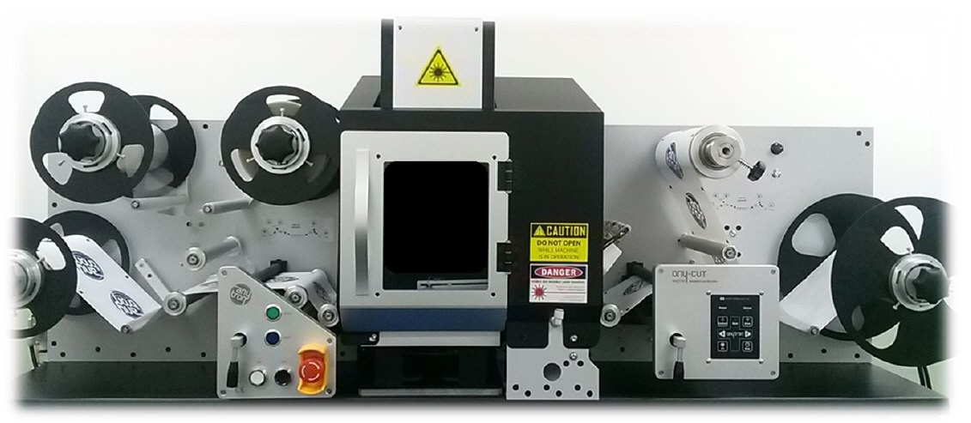
  - Introduction to Equipment
• This equipment facilitates the one-stop post-processing (laminating, cutting, removal of scrap paper) of labels after they are printed on digital printer. By using laser instead of conventional knife as the cutting media, it has solved the root of the problem experienced with the knife die cutting machines, and is compact sized down to a desk-top size.
• The equipment consists of 7 Unwinders, the Rewinder unit, the laminating unit where the media and the film are laminated, the label feeding unit, the laser cutting unit that cuts labels, the removal unit that removes scrap from the cut labels, the display unit that displays the processes and the control unit that controls the entire equipment.
• Lateral movement or smoothness of the media while it is on the move is critical in the roll-to-roll system. With this equipment, vertical movement of the tension bar is driven by elasticity of the media facilitating perfect control of the motor of each Unwinder and Rewinder, and the cutting unit utilizes a suction pad to ensure accurate cutting without shaking. By applying ‘Vision’, the cutting errors often caused by media, printing errors are minimized; by designing the laser scanner module to move vertically, the cutting conditions can be setup more accurately; and various processes (such as kiss-cut, full-cut, marking etc) are enabled.
  - Installation Standard
    - Outline
- This equipment is a printer/cutter, and at the same time, is a digital communication device. This means that the equipment is required to be installed under the environment suitable both for a label printer/cutter and also for a digital device to ensure optimum printing quality. For this reason, the equipment is normally installed by the Company’s qualified technician or by the Company’s agent at the customer’s premise and customers are required to follow instructions or recommendations of the above personnel with regards to the place and environment for installation.
    - Place and Environment
- The Product shall be installed under the following environment at a place that meets the temperature/humidity requirements. It shall be on top of a level shelf that could stand 3 times the weight of the Product. It is essential to keep the workshop clean and free of dust to ensure best printing quality.
    - Delivery (by the installation technician) and Acceptance
- In principle, the Product is installed by the Company’s (or the agent’s) staff at the customers’ premise. Please contact us if you have any question regarding our installation service:
E-mail: / Tel:
- Upon installation of the Product and the accompanying software the technician will test print a roll (continuous paper) to see if the installation has been successful. If successful you are required to sign the delivery note to declare that delivery has been successfully made.
  - Structure Installation
    - Installation Check and Caution in Transportation
- The Structure (Press Station) is not just a simple shelf for devices, but a sophisticated Smart station to mount the Unwinder, the Rewinder, the Tension Bar, the Paper Press, the Sensor, the Cutter and etc which are connected through the electronically controlled semi-conductor circuits and by wires. It requires caution during transportation and installation. Please observe this Manual and the instructions of the installation staff.
- This Structure weighs 190kg and its dimensions are __(L) * __(W) * __ (H), and requires at least 4 men to move. An electronic circuit board is located at the back of the Structure, and the Structure is best to be installed as close to the wall as possible for stability.
- Safety
  - Safety Caution
- Please observe the safety caution to ensure safe and correct use of the Product and to prevent accident or hazard.
    - During Installation
- Install in a stable place free of risk of falling.
- Install in a place away from high temperature or humid as it may cause malfunction or electric shock.
- Do not use loose consent or damaged power cord as it may cause electric shock or fire.
- Plug in the power cord in a grounded consent (or a multi-consent).
    - During Operation
- Do not allow unauthorized maintenance/repair of the Product.
- Do not disassemble. Do not apply impact.
- Do not use or store the Product near magnet.
- Do not use the Product in a place exposed to electromagnetic interference.
- Do not place an object on top of the Product, which is heavy or may spill.
- Do not use chemical or detergent to clean the Product.
- Use only the program provided or approved by Bitek.
- Do not open the front door during operation.
- Warming: Do not get your body, directly or indirectly, in contact with laser beam.

  - Caution in Equipment Operation
The following instructions shall be observed and proper education/training course be completed by the personnel who installs or operates this Equipment.
- Anyone who is allowed an access to this Equipment during operation must be properly protected against laser (such as goggles, protective cloth etc).
- Please exercise caution during operation as the reflected light may also be hazardous.
- The path of laser beam is blocked by a cover; exercise care as and when you block the path of laser beam during maintenance.
- A warning sign must be provided in the place where laser equipment is in operation so as to prohibit unauthorized access.
- Electric Safety for Laser Device: This Laser System uses 220VAC Single-Phase power. The voltage and the current inside the device is very high. If the cover of laser or controller needs to be open, turn power off first.
  - Laser Safety
- Laser is widely used in applications in almost all industries, including medical diagnosis and treatment, laser processing, optical communication, optical information storage, special laser development, environmental measurement, automobile, aerospace, national defense, industrial process diagnosis and laser show for its unique characteristics (linearity, monochromaticity, coherence and high energy output), and therefore not only the laser professionals but also non-professionals are exposed to laser.
- Laser safety is divided into laser beam safety and safety of electric device on the laser generation unit (as well as the power unit). Laser beam safety aims at safe use of the benefits that come from the laser technologies by protecting the cornea and the retina from being damaged owing to the direct radiation, reflection or scattering of laser beam, or the skin from burn or development of red spot owing to laser beam.
The international standard for laser safety level, as the standards of laser safety, classifies laser hazard levels and prescribes safety provisions based on the MPE (Maximum Permissible Exposure) under all possible operational conditions including malfunctions and deviations from normal operation. To be safe from laser, laser must be classified based on accurate measurement (such as laser output, mode, characteristics of the wave etc), and laser users must observe safety regulations of the corresponding laser class to protect not only themselves but also those non-users in the vicinity.

  - Principle of Tissue Damage by Laser
- Lasers can cause harm because of their ability to produce higher concentrations of optical radiation than is normally possible with other kinds of light source. Their monochromaticity in particular, can give rise to very selective interactions, so that the particular tissues at risk. The potential for causing hazard was recognized soon after the introduction of the laser, and in consequence investigations into the mechanisms of laser damage and the thresholds for safe exposure levels have proceeded in parallel with the development of laser technology.

The eyes are known to be more vulnerable to laser light source than the skin or other tissues. The optical energy radiated is collected in a very small area due to its optical characteristics, and as a result all the highly concentrated laser radiation can be focused to a very small spot on the retina exposed to laser. In addition to such high damage probability to the eye, the skin is also known to be relatively vulnerable to damage.
The biological effects of laser radiation on the human body are complex and can vary depending on the angle of laser beam radiation, time of exposure, pulse repeatability, energy density, radiation area and etc. Therefore, MPE also varies by part of the body depending on the characteristics of laser.
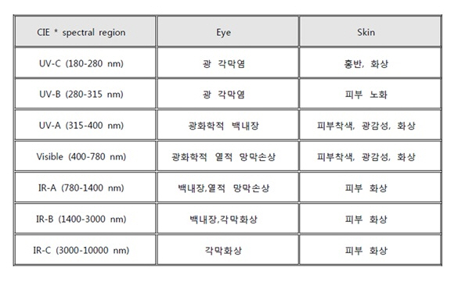
CIE * spectral region | Eye | Skin
UV-C (180-280nm) | Photokeratitis | Red spot, Burn
 | Photokeratitis | Skin aging
 | Photochemical cataract | Skin pigmentation, Photosensitive, Burn
 | Photochemical thermal retinal damage | Skin pigmentation, Photosensitive, Burn
 | Cataract, Thermal retinal damage | Skin burn
 | Cataract, Corneal burn | Skin burn
 | Corneal burn | Skin burn

  - Safety Label

- The entrance (path) of laser beam

- Laser Equipment

- Warning: Avoid eye or skin exposure to direct or scattered radiation.

- Warning: Do not open the door while the laser device is in operation.
  - Safety Device
C
B
A
Laser shall not be in operation when the door to the laser operation area is not properly closed. The operation status of the safety device can be grasped by READY LED.
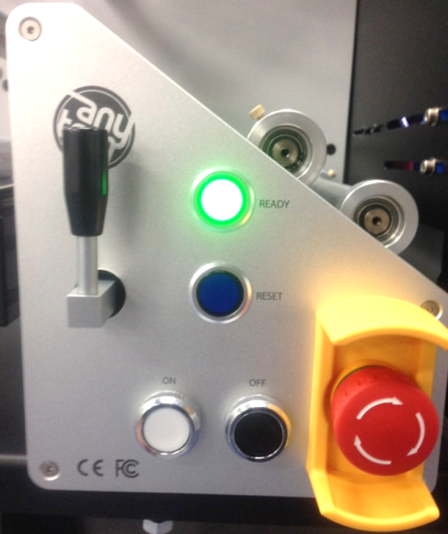
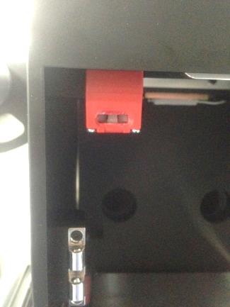 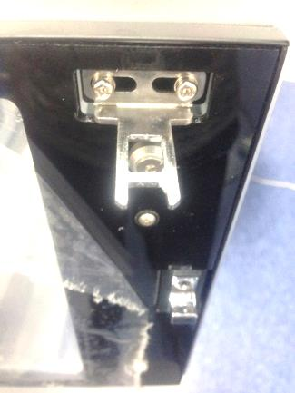
(A) READY LED
(B) Safety device inside the door
(C) Safety device outside the door
- Laser operates only when (B) and (C) are fastened.

- Any-Cut System Configuration
  - Appearance
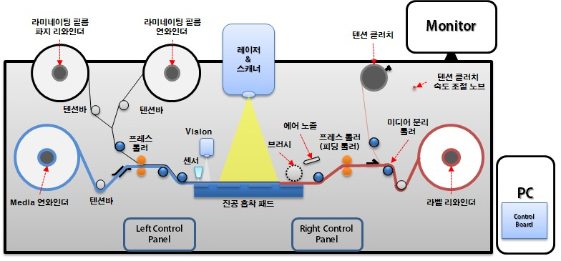
  - Name and Function of Parts
    - Unwinder Unit
- Media Unwinder: the bobbin on which the printed roll is mounted
- Laminating Film Unwinder: the bobbin on which the Laminating Film is mounted
- Laminating Film Scrap Unwinder: the bobbin on which the scrap (Release Paper) of the Laminating Film is mounted
- Press Roller: The Press Roller used to mount the Laminating Film
- Panel Unit
• Green LED: Ready LED
• White Button: Laser Power on
• Black Button: Laser Power off
• Emergency Button
    - Safety Door Unit
- Scan Head: to control laser positions
- BM Sensor: used in black mark (to locate the start point of the image) sensing
- Vision Camera: to correct the cutting position
- Brush: to remove dust during cutting
- Vacuum Pad: to maintain flatness of the printed surface during cutting
- Air Nozzle: The air supplying unit to maintain cleanness of the dust removing brush
    - Rewinder Unit
- Label Rewinder: to rewind the cut paper
- Press Roller: to feed paper
- Scrap Rewinder: The tension clutch used to remove scrap from edges of the label area
- Scrap Removal Roll Button: The ON/OFF button to operate the Scrap Removal Roll
- Scrap Rewinder Volume Button: to adjust speed (force) of the Scrap Rewinder
- Control Panel:
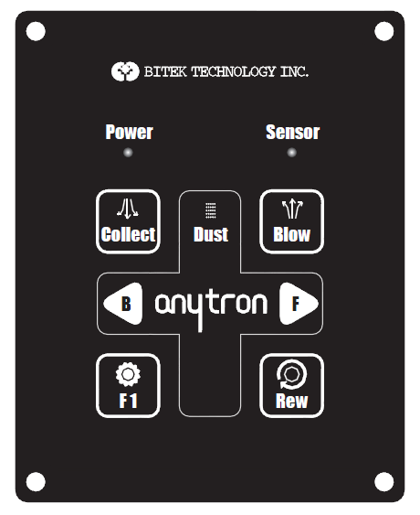
① LED
- Power: The Power LED is illuminated in red when power is turned on.
- Sensor: The Sensor LED is illuminated in blue when it recognizes a mark.
② Button
- Collect: The ON/OFF button to operate the external dust collector
- Blow: The manual button to operate the air nozzle (this is used to remove dust off the brush that is provided to remove remaining dust after a label cutting)
- B: The Back button to feed paper in reverse direction
- F: The Feed button to feed paper in forward direction
- F1: A function key
- Rew: The button to rotate the Rewinder
- F1 + Blow: The manual button used to operate the vacuum pad. Press F1 during operation to stop.
- F1 + F: The button to feed paper in forward direction continuously. Press F or B once during operation to stop.
  - Laser System
- A laser system, although it looks simple, is an integrated body of electronics, machinery, optics, physics and so on. The following parts are used to form the laser system for Any-cut.
1) Laser Source
- Laser source is a device where actual laser oscillation occurs. Any-cut uses CO₂ laser that has the most suitable wavelength range, which is installed inside at the back of the equipment.
2) SCAN head & F-theta lens
- SCAN head is used to move accurately within the application area laser beam that is coming out of the laser source. SCAN head consists of 2 motors, 2 mirrors mounted on the motor and an electric board. The F-theta lens is fitted to the lower part of the Scan head to combine laser beams. Since this lens is exposed outside, it is vulnerable to contamination if the work shop is unclean or not properly equipped with dust collector. Therefore the lens shall be checked for contamination after each operation.
3) B.E.T
B.E.T standing for Beam Expander Telescope, is used to enlarge the beam size.
The beam quality in a laser cutting device directly affects the product quality. To obtain better quality, a proper setting is essential to specification of each laser part. B.E.T is used to adjust the beam sizes coming out of the laser source and the beam sizes received by the scan head since they differ from one another.
4) Guide Beam
- Guide beam is a very weak laser beam having the visible spectrum. Laser beams of various colors exist within the visible spectrum but the red laser beam is used in this equipment (as same as the laser pointer). Laser beam is not visible, so through the guide beam you can clearly check the cutting area/speed.
5) Beam combiner
Beam combiner is used to combine laser beams of two different wavelength ranges. In general, it is used to combine and move two different beams by letting the laser beam pass through but reflecting the guide beam at 90 degrees. With this principle, the operator can use invisible laser beam for cutting as if it is visible.
6) Control board & Fly board
The Product uses two boards, one that controls two mirrors of the Scan head, and the other that controls the ‘on the fly’ during marking.
  - External Device
    - Dust collector
- A lot of smoke and dust is generated during marking as most materials processed with the Product are non metallic. It is hazardous to the human body to inhale dust, and lenses contaminated by dust will be damaged when laser beams pass the contaminated area as laser beams react to dust. To prevent such hazard a dust collector is used.
    - Compressor
- The Product is designed to prevent shaking of the media by applying the vacuum system on the cutting base on the floor as high cutting errors occur if the paper is moved during the cutting operation. It is also designed to have clear media by air blowing off the media residue after cutting. Compressor is used to operate these two systems. Compressor utilizes ambient air, and then pressurizes and stores it for further use.
    - PC
- PC is embedded with the PSC14xP board to control the laser system.
- Installation of Any-Cut System
  - Connection of Equipment
Step.1 | 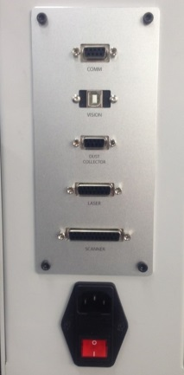 | Check the cable connector on the left.
Step.2 | 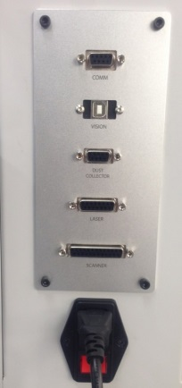 | Connect the power cable.
Step.3 | 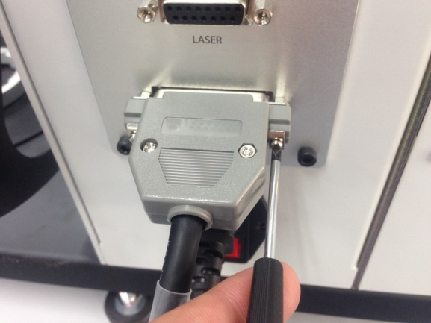 | Connect the cable and fasten using the screws on both sides.
Step.4 | 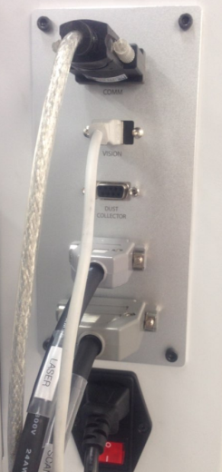 | Connection between the Station and the cables is complete as shown in the left.
Step.5 | 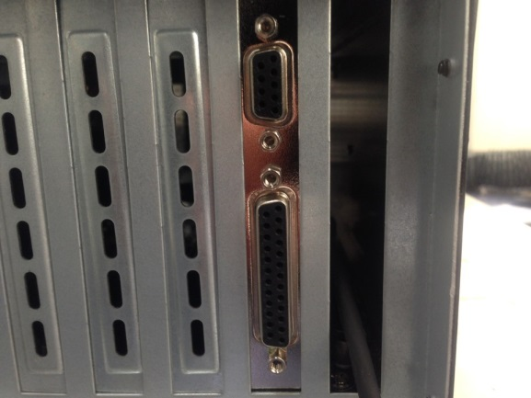 | Check the Laser Control Board Port at the back of the PC’s main body.
Step.6 | 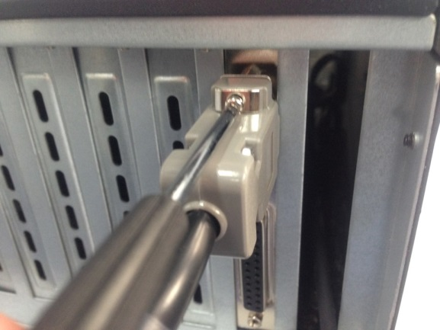 | Check the pin for each connector and fasten by tightening the screws on both sides.
Step.7 | 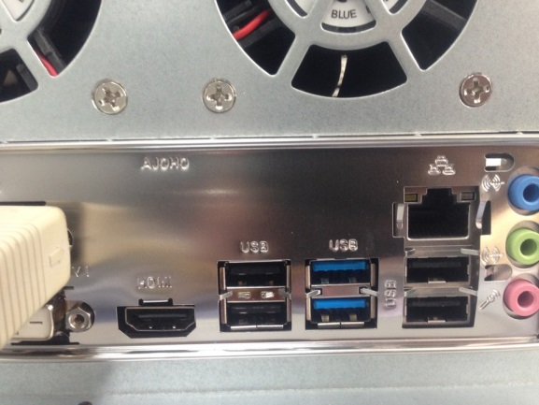 | Check the USB ports at the back of the PC.
Step.7 | 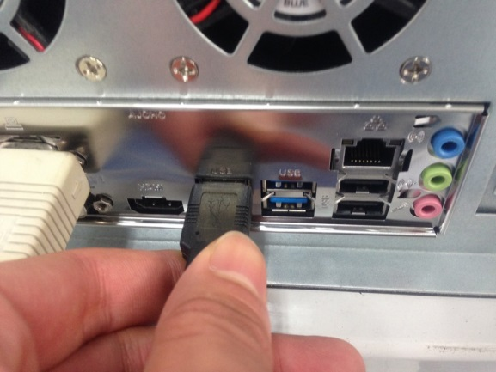 | Connect to the USB port.

  - Items to be Checked Before Operation
- Checking the Power and System Operation
Step.1 | 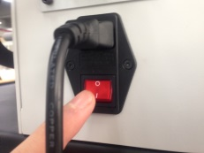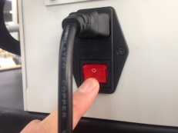 | Turn on the power button.
Step.2 | 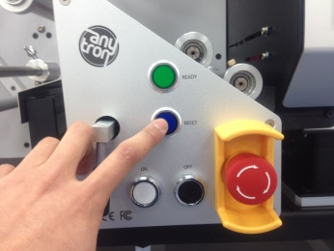 | Press the ‘Reset’ button.  (This is essential when power is turned on for the first time.)
Step.3 | 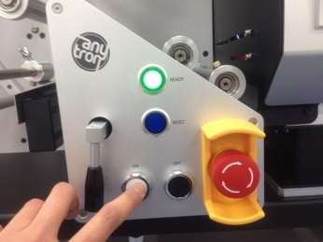 | Press the ‘ON’ button and see if ‘Ready LED’ is on.
Step.4 | 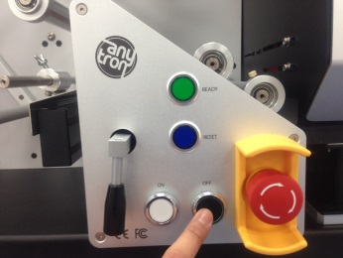 | Press the ‘OFF’ button to see if the system is turned off normally.
Step.5 | 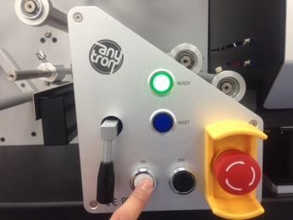 | Press the ‘ON’ button again to see if ‘Ready LED’ is turned on normally.
- Checking the motor operation
Step.1 | 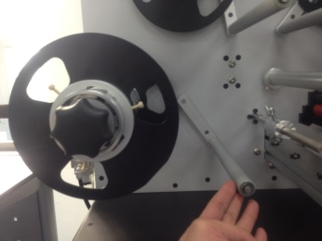 | Check the tension bar of the Unwinder.
Step.2 | 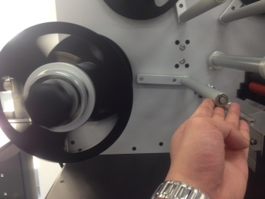 | Check if the motor rotates when the tension bar is lifted up.
Step.3 | 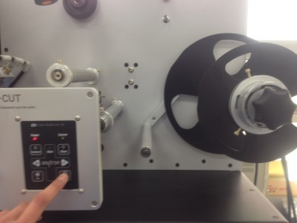 | Check the Rewinder Unit, and press the ‘REW’ button on the Control Panel to see if the motor rotates.
Step.4 | 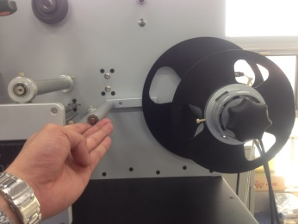 | Life up the tension bar of the Rewinder to see if the motor stops.
Step.5 | 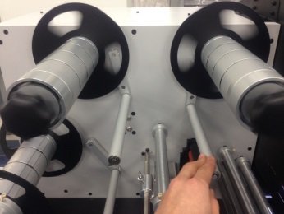 | Lift up the tension bar of the Unwinder at the Laminating Unit to see if motors on both sides rotate.
Step.6 | 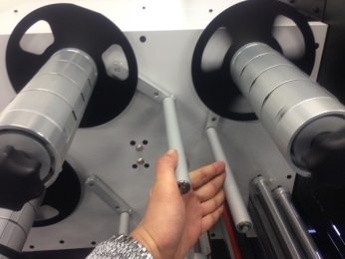 | Lift up the Rewinder tension bars at the Laminating Unit simultaneously to see if only the laminating rewinder motor stops.
Step.7 | 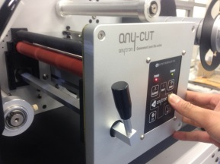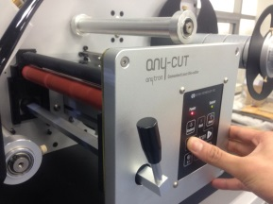 | Press the ‘F’ and ‘B’ buttons to see if the roller operates normally.
Step.8 | 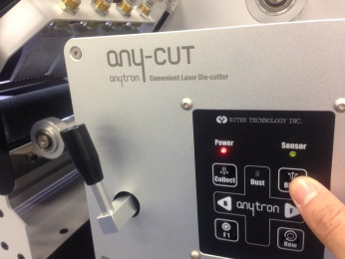 | Press the ‘Blow’ button to see if the internal brush roller rotates normally.

- To Use Any-cut
- To Use Station
  - Entire Paper Path
- Install the Product in consideration of the rotating direction of the bobbin along the paper path.
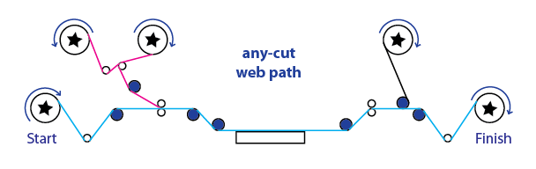
  - Mounting the Media
- Mount the printed paper with reference to the Cyan path shown in the above Figure 1-1.
In general, the paper is aligned to the left. Scales are printed on each Unwinder, Rewinder and Shaft. Upon aligning the guide on the left, mount the paper.
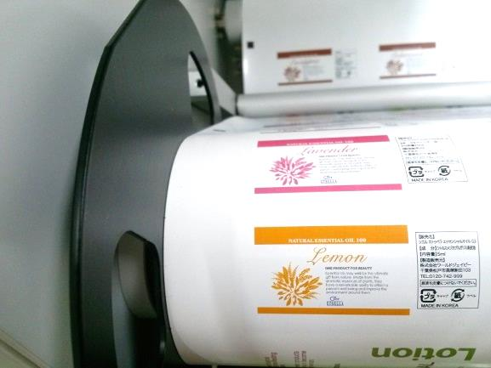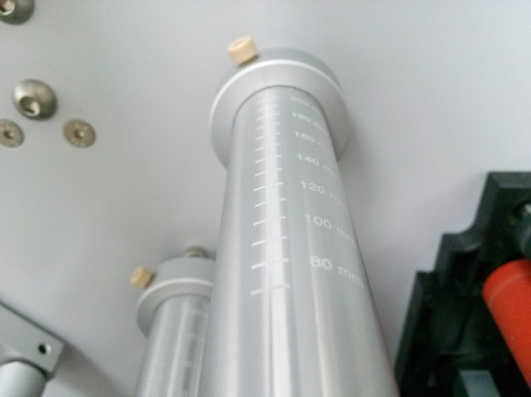
  - Mounting the Laminating Film
- Mount the laminating film with reference to the magenta path shown in the above Figure 1-1.
1 | 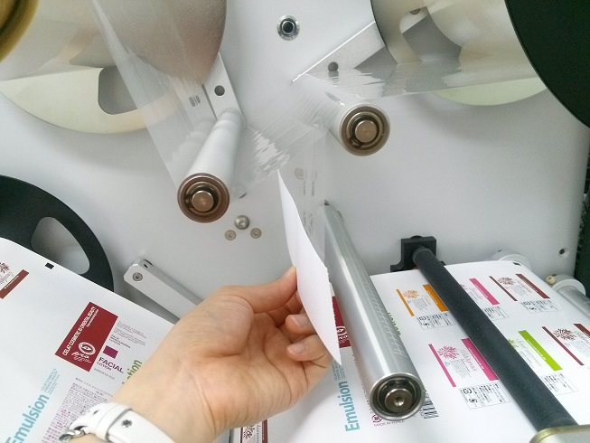 | - Pull the paper part of the laminating film along the path.
2 | 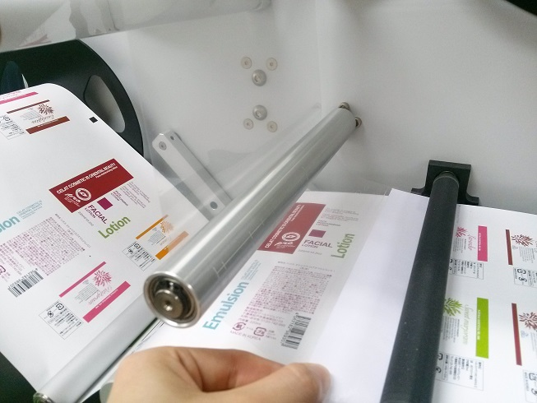 | - Insert it underneath the open press roller.
3 | 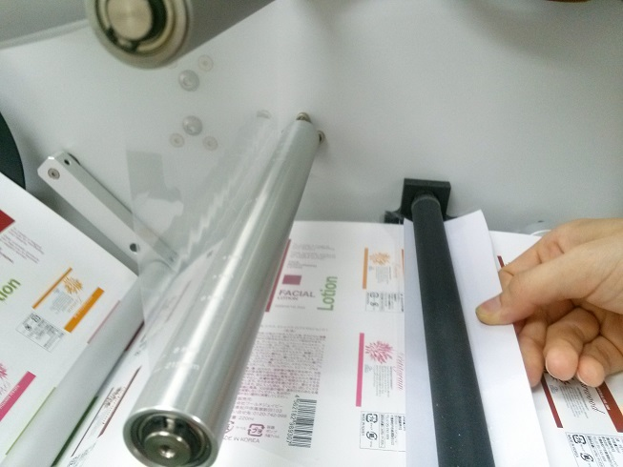 | - Pull from the opposite side of the open press roller and affix the film at the bottom.
4 | 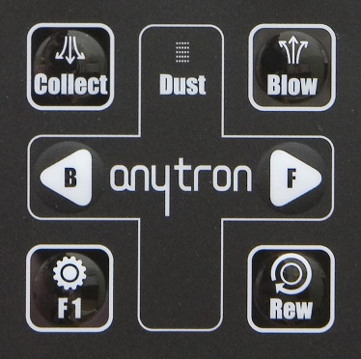 | - Press the F(Feed) button to move the paper forward by about 50 cm.
5 | 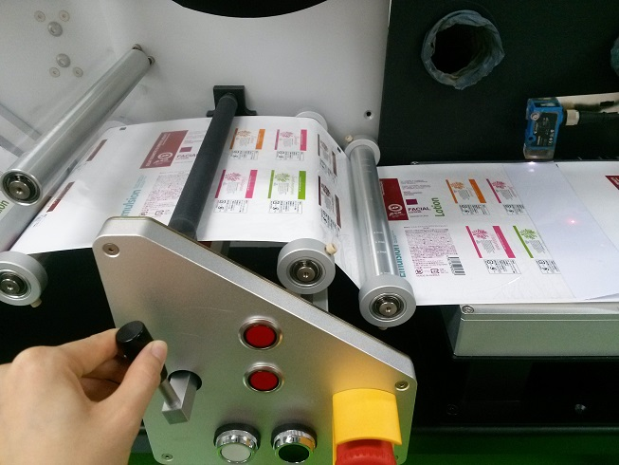 | - When the paper part reaches the middle of the vacuum pad as shown in the picture, close the press roller and press the F(Feed) button to move it, then the laminating film is adhered to the label paper.
6 | 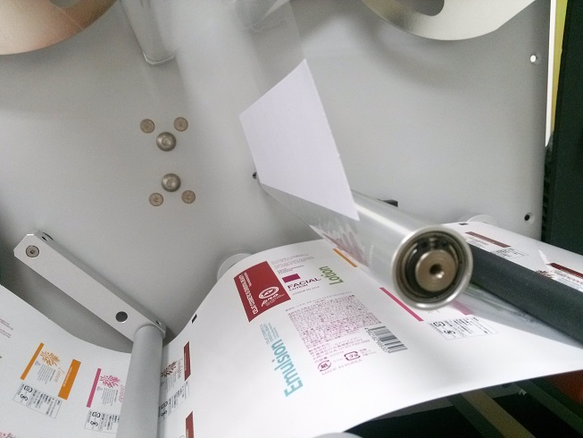 | - To remove the laminating film, affix a paper (in the width of the film width times 50 mm) as shown in the picture.
7 | 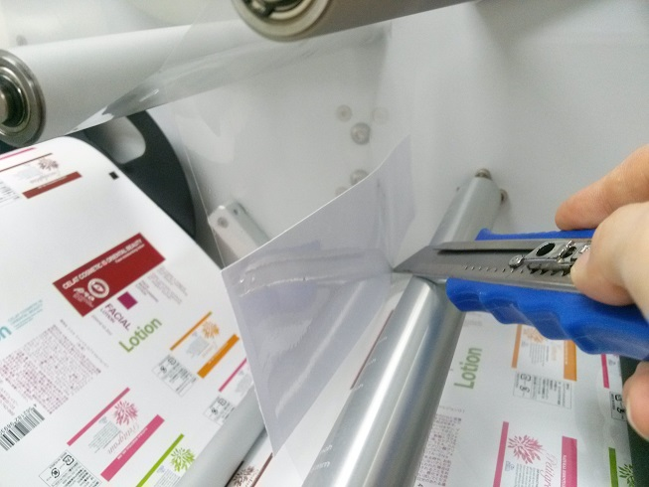 | - Cut off the bottom of paper as shown in the picture to neatly remove the paper. It can be re-used next time when you use the laminating film.
  - Mounting the Scrap
1 | 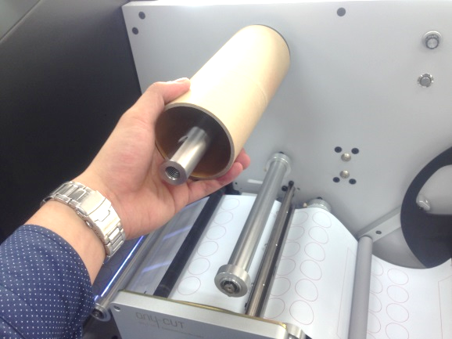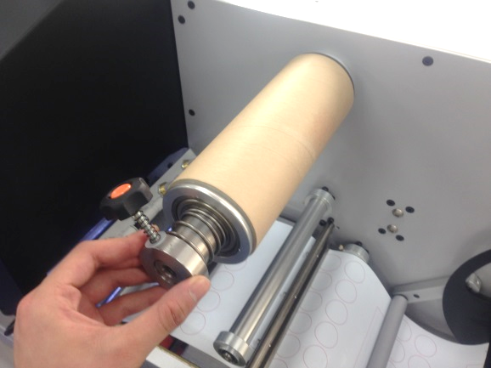  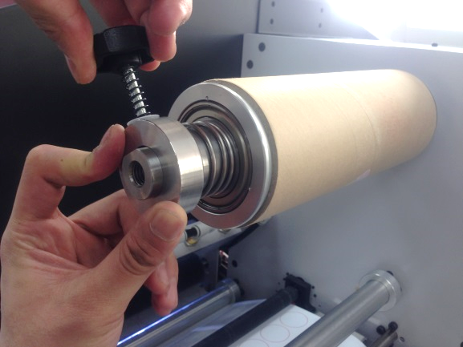 | - Mount a paper core on the tension clutch and apply a bit of force to the spring to fix the core.
2 | 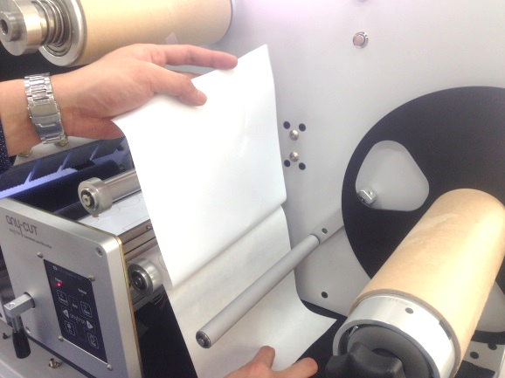 | - Separate the paper scrap that comes out of the Rewinder.
3 | 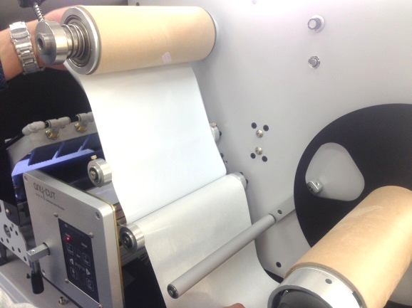 | - Affix the scrap to the tension clutch paper core.
4 | 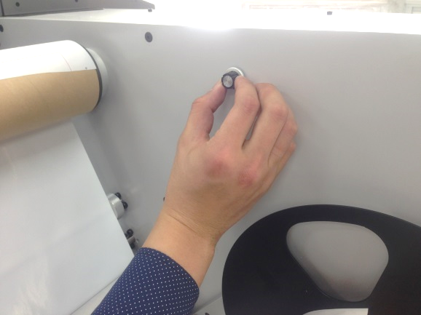 | - Adjust the tension clutch knob.  (Left to speed up, Right to speed down)
5 | 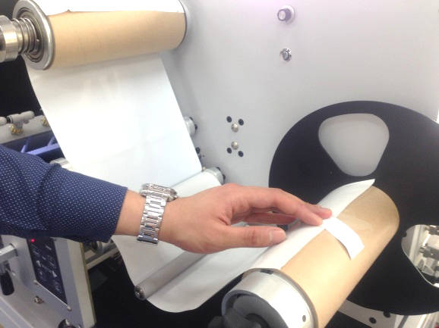 | - Affix the remaining paper to the Rewinder along the path shown in the picture.
6 | 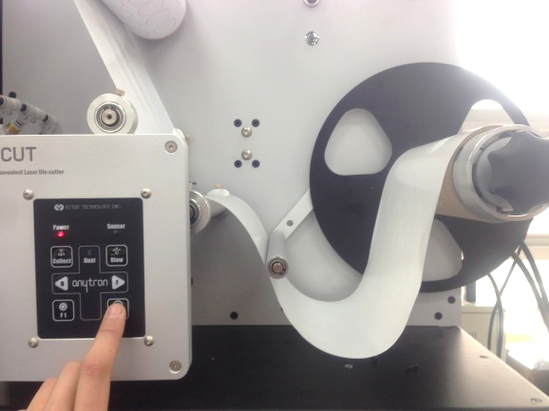  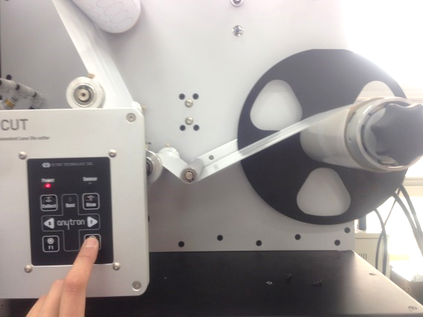 | - Press the Rew button on the Control Panel.  - The tension bar must be positioned at the lowest point before turning power on.  (The tension bar at the moment of power-on is stored as the initial position.)

  - Sensor Setup
- The sensor is used to identify the start point of an image. When a new paper is used, a new value must be memorized to the sensor through auto sensing. Note the steps for auto sensing as follows.
- Auto Sensing of Black Mark Sensor
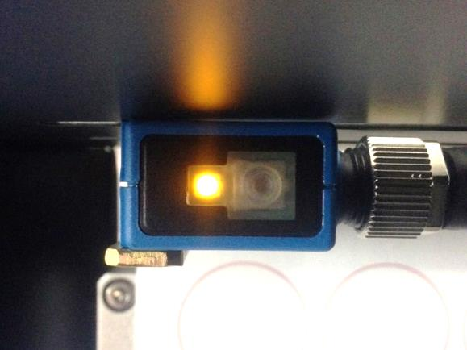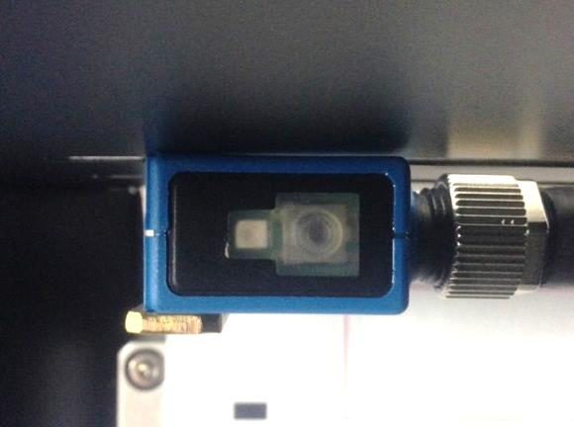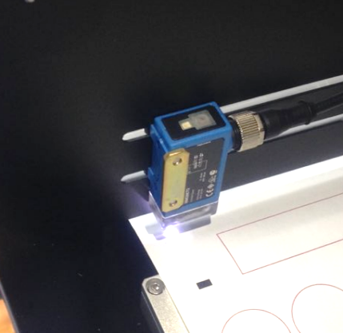
Press and hold the button above the black mark as shown in (A).
Press the button briefly once over the white paper to complete the setting as shown in (B).
(C) This is the completed sensor position.
- Checking to see if the sensor is properly set:
Move the paper forward and backward for the black mark to be sensed. If LED on the sensor button is illuminated over the black mark, it indicates that the setting is completed property, and this is also verified by the MARK LED at the front panel of the Product as shown below.
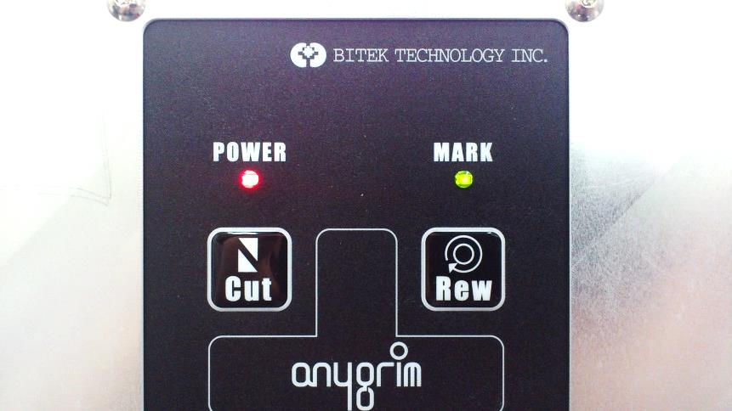 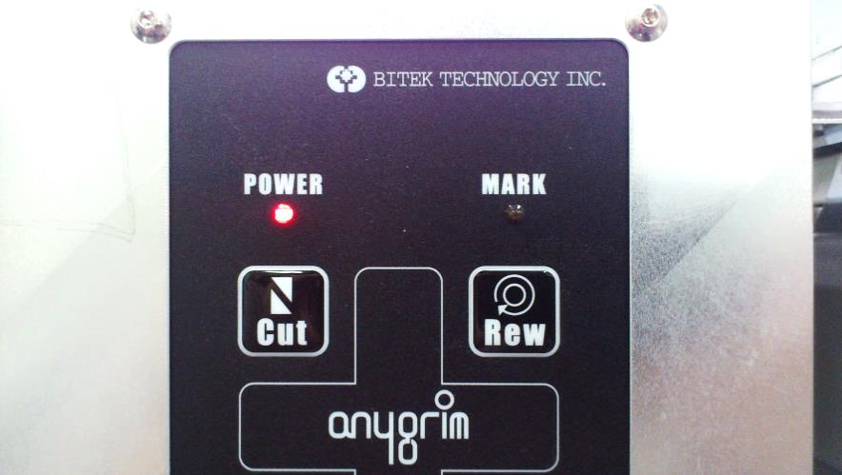

- To Use Software
▶ Please refer to the Software Manual for further information.
  - Description of and Setup Values for Beam Cut
- Beam cut is used as a server (driver) to control the laser source, the head and the PSC14xP board, and is a program that executes processes required by Adobe Plug-in.
- The following steps for setup are required to enable interaction:
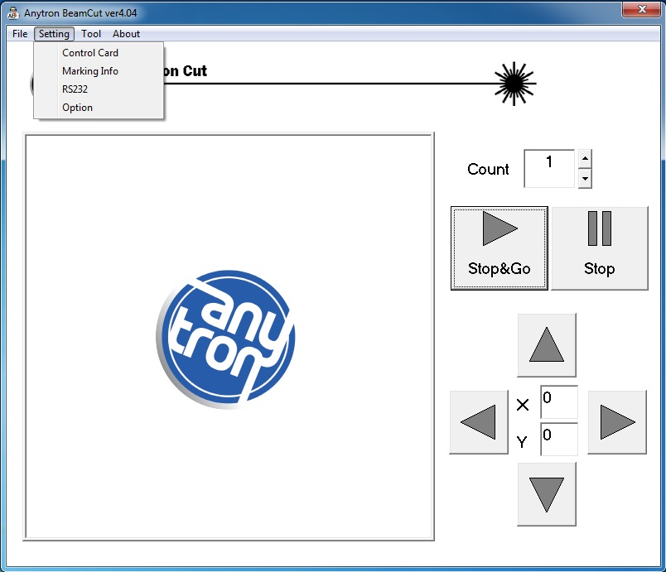
① Control board
- The file inserted by the installation technician must be used as is.
Users are NOT required to amend values.
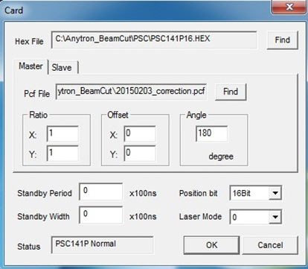
② Marking Information
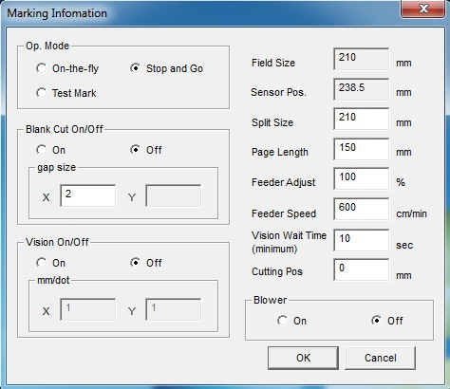
(A) 3 modes are available.
(B) The Blank Cut function can be turned on or off. Gap sizes can also be adjusted.
(C) The Vision system can be turned on or off.
(D)
- Split Size: This is a single operation length for split marking.
A
B
C
D
E
Document

- Page Length: the distance between marks
- Feeder Adjust: the volume of paper feed
- Feeder speed: the speed of paper feed
- Vision Wait Time: the standby time of the Vision system
- Cutting Pos: to adjust the cutting start point
(E) – This is the blow operation button used to remove dust generated during cutting.
③ RS232
- The serial port detected by the station is set during the connection between PC and the station.
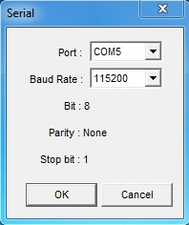
④ Option
- This is used to adjust the feed when the joy stick is used to adjust the position of the cutting areas.
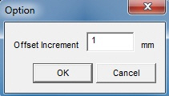
  - About Adobe Illustrator plug-in
- The top left corner (0, 0) of the paper (art work) must be initially set to ‘210x210mm’ to enable Anytron plug-in as shown in the following picture.
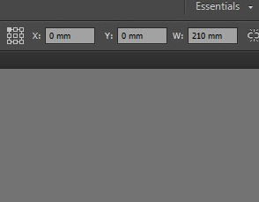
- plug-in items are located under Window on the top menu bar.
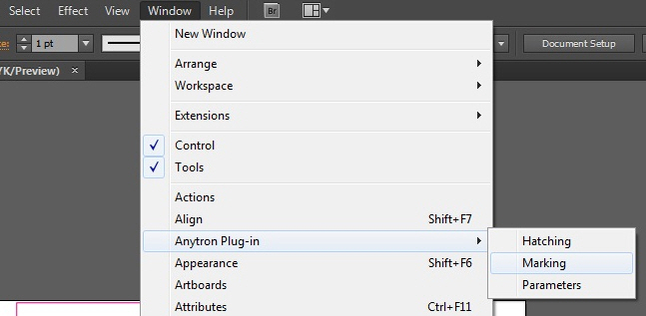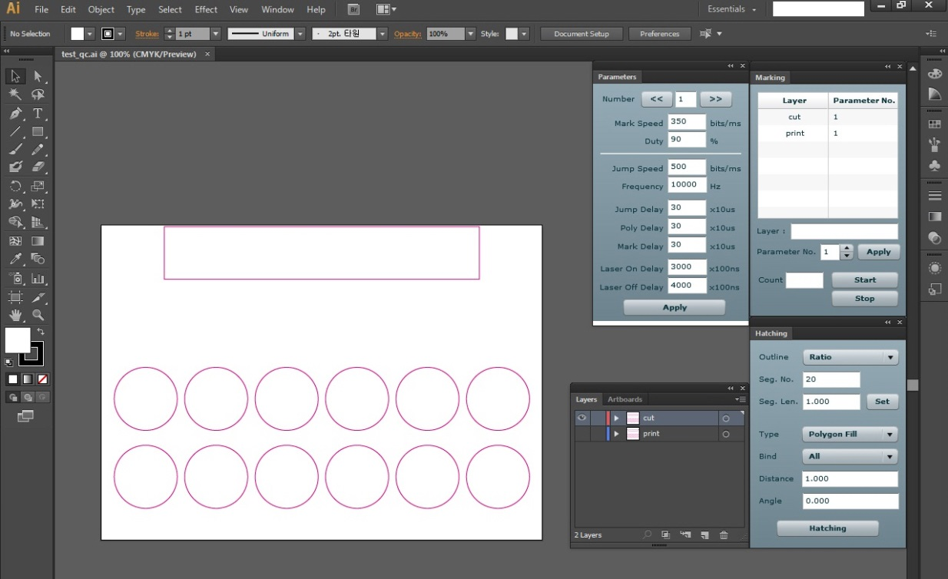
    - Parameters
- Parameters can be preset.
- Each ‘Delay’ is elaborated under ‘2-3 About Delays’.
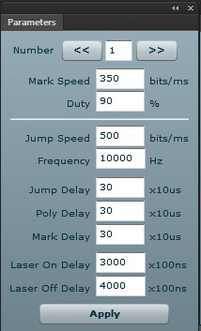 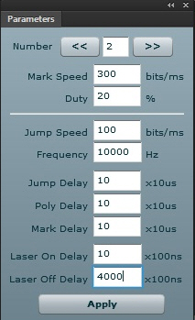
- Cutting suitable for each paper type can be determined by adjusting the Mark Speed and Duty.
Note the following recommendations for Art Paper, White PET, Clear PET and White PP.
 | Paper Type | Duty (%) | Mark Speed | Remarks
1 | Art Paper | 90~95 | Normal | - Reference values for Stop and Go  - Use lower values for curved shapes; use higher values for angular shapes.  - Values may vary depending on the paper manufacturer, adhesive, laminating film type.
 |  |  | 180~200
 |  |  | With
 |  |  | 160~180
2 | White PET | 90~95 | Normal
 |  |  | 250~280
 |  |  | With
 |  |  | 230~270
3 | Clear PET | 80~90 | Normal
 |  |  | 400~500
 |  |  | With
 |  |  | 250~300
4 | White PP | 90~95 | Normal
 |  |  | 270~280
 |  |  | With
 |  |  | 170~200

    - Marking
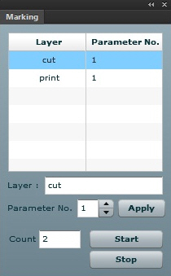 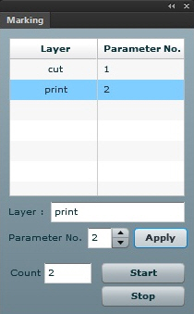
- The value saved for each parameter can be applied to each layer.
To change q’ty
- Count: You can set the number of cuttings.
- Information of each layer is transmitted to the ‘BeamCut’ program when the Start button is clicked on.
    - Hatching
- Hatching works in the concept of ‘filling the shape of your choice. It is normally used for marking, rather than cutting.
- Upon selection of a shape in the layer of your choice, a multiple hatching is enabled by using ‘Distance’ and ‘Angle’ values.
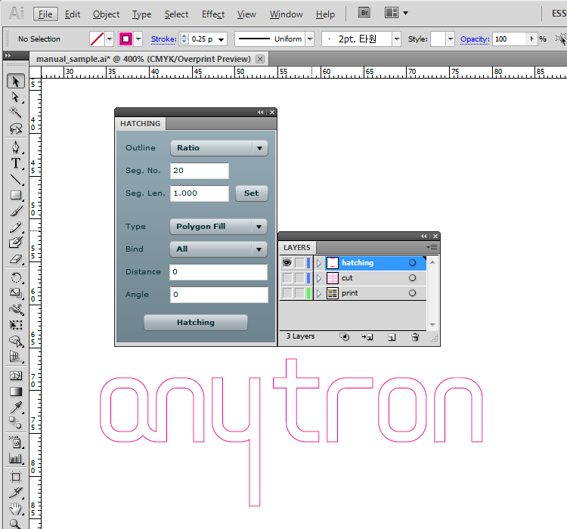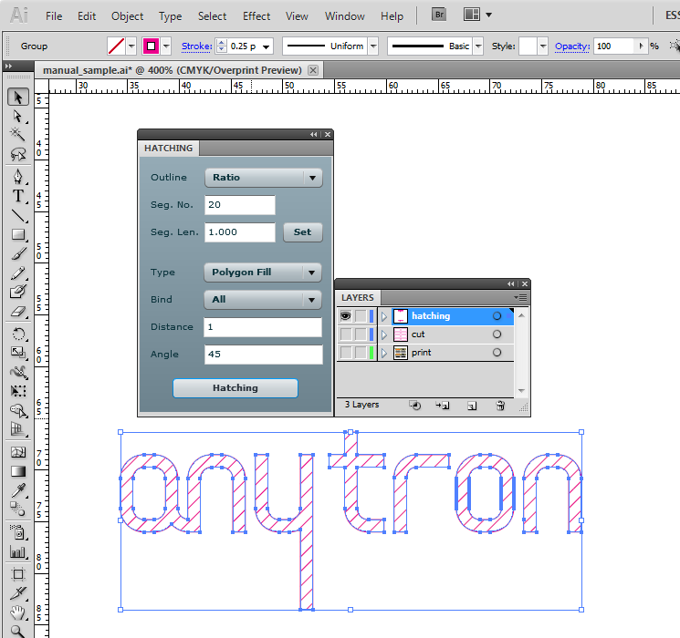
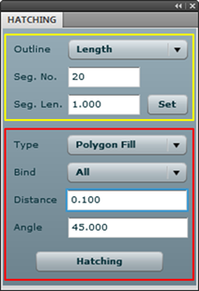
- Outline: To convert Bezier curve of AI to a vector
- Seg. No.: To determine the number of vectors
- Seg. No.: The Bezier curve is cut by the entered value in ‘Seg.No’ to convert to a vector.
- Type: To select a method of distinguishing the hatching area through the extracted vector
- Bind: To select a method of creating the hatching line
- Distance: The distance of the hatching line
- Angle: The angle of the hatching line
  - To Understand Delays
- The timing/laser control signal of the scan head and the operation of the scan system must be compatible with one another. In other word, a particular interaction must be present between the scanner, laser reactions and laser beams. You need to understand following delays to enable the foregoing interaction.
Type of Delays:
- Laser On delay, Laser off delay
- Jump delay
- Mark delay
- Polygon delay
    - Laser Delays / Scanner Delays
- Type of Laser delays: LaserOn delay , LaserOff delay
- Type of Scanner delays: Jump delay, Mark delay, Polygon delay
With respect to ‘laser delay’, the status of laser when it is ON, OFF, before ON and after OFF will affect Mark, Arc command or a series of commands.
‘Laser delay’ does not affect the overall marking time unless laser is in abnormal status.
    - Optimizing Delays
- The following cases show various consequences in using of the letters “RTC” when delays are not optimized.
• Laser ON Delay is too short (Example 1)
- Even the reflector has not reached each of the required speeds, laser is turned on at the start point of the vector. Consequently, the burn-in effects appear at each start point of the vector. This indicates that laser is turned on earlier than normal.
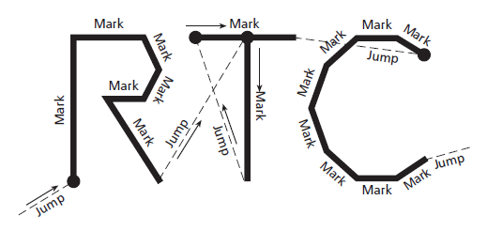
(Example 1)
• Laser ON Delay is too long (Example 2)
- If ‘Laser ON Delay’ is too long for a mark vector, each vector is disabled to mark at its start point. This indicates that laser is turned on later than normal.
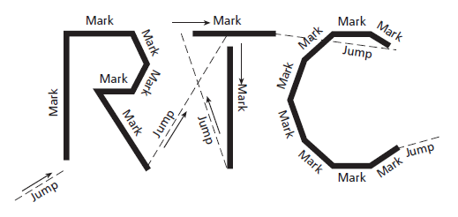
(Example 2)
• Laser OFF Delay is too short (Example 3)
- Laser is turned off after a Mark command even though the reflector has not reached the end point of the vector. Consequently, each vector does not have a perfect marking. This indicates that laser is turned off earlier than normal.
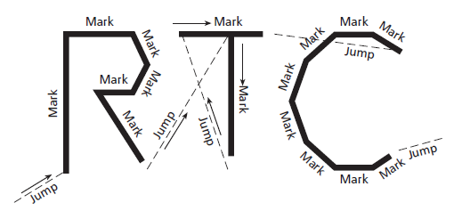
(Example 3)
• Laser Off Delay is too long (Example 4)
Laser OFF Delay is too long (Example 4)
If laser is turned off too late after a Mark command, the Burn-in effects occur at the end point of each vector since laser is left on even though the reflector is properly delayed or stopped.
This indicates that laser is turned off later than normal.
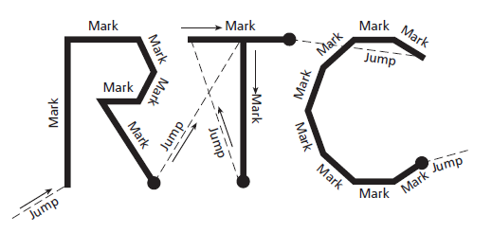
(Example 4)
• Jump Delay is too short (Example 5)
- The next vector will have been marked before it reaches the required jump time by the jump command. Consequently a wave shaped or shaken mark will be obtained. This indicates that laser is turned on before laser reaches the ‘start mark’ point.
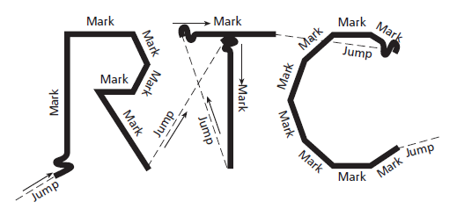
(Example 5)
• Jump Delay is too long
- It will not affect quality even though the jump delay is too long, but the overall operation time will increase.
• Mark Delay is too short (Example 6)
- If the next vector command begins before the reflector reaches the final end point, mark or vector will be converted to the next vector’s direction. This indicates that laser jumps to the next marking point before completion.
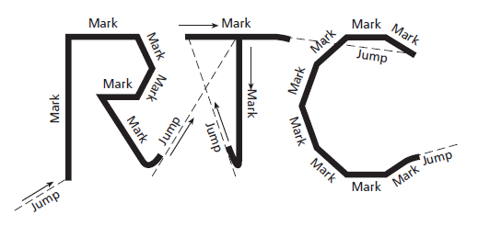
(Example 6)
• Mark Delay is too long
- This will not affect the mark visually, but the scan time will increase.
• Polygon Delay is too short (Example 7)
- The corner of serial vectors is in the circular shape. The command will have been completed even though the reflector has not reached the final point of the successive vector. This indicates that it will move to the next vector before reaching the final end point.
This occurs when laser continuously marks the angled area without being turned off.
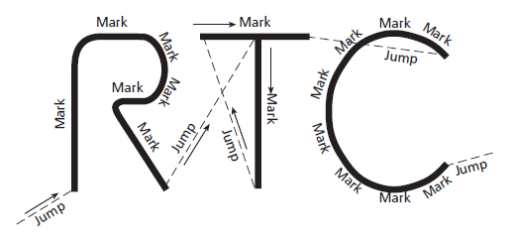
(Example 7)
• Polygon Delay is too long (Example 7)
- If ‘Polygon delay’ is too long, the reflector will delay or stop at the final end point of vector. Consequently the burn-in will occur at the final end point of vector as if laser has stopped.
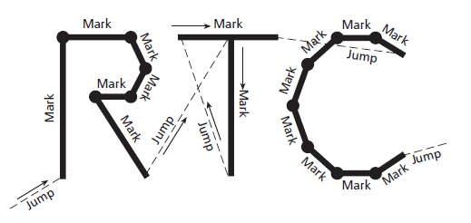
(Example 8)

- Maintenance
- Maintenance and Control
  - Lens Maintenance
- Lens shall be cleaned periodically as it can be contaminated by dust or soot.
(1) Turn the lens which is located underneath the scan head, clockwise to remove.
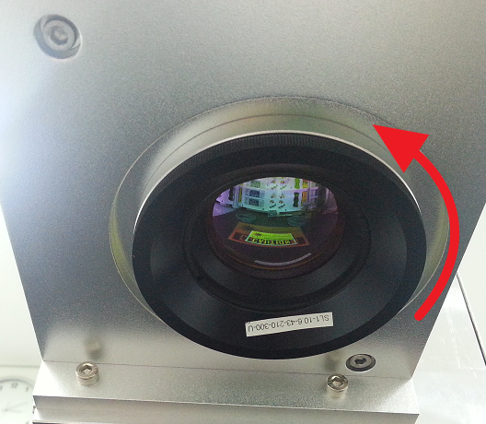
(2) Have a lens cleaning tissue ready.
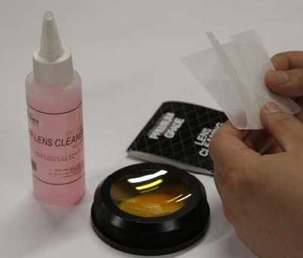
(3) Wet the tissue with lens cleaner.
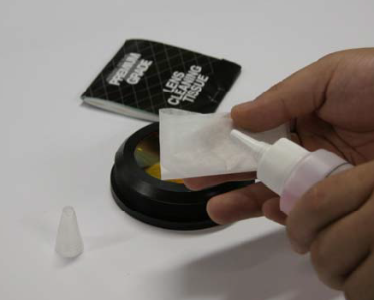
(4) Clean the lens surface with tissue in a circular motion. Do not press the lens surface during cleaning.
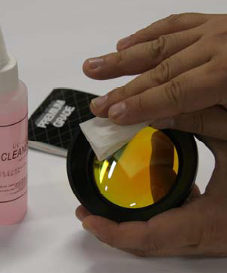

  - Cleaning of Vacuum Pad
The vacuum pad is porous. Through these pores a paper is adhered to the upper side of the pad. When the pores are blocked, the pad cannot properly absorb the paper. To ensure good cutting quality, the pad needs to be cleaned periodically.
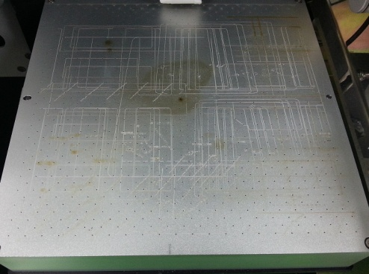
(1) Loosen the screws to separate the upper part of the pad.
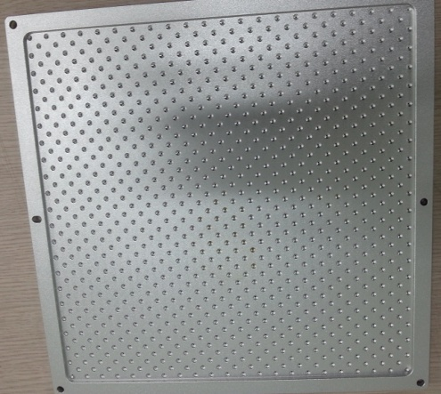
(2) Use cleaner to clean the holes and the surface of the upper part.
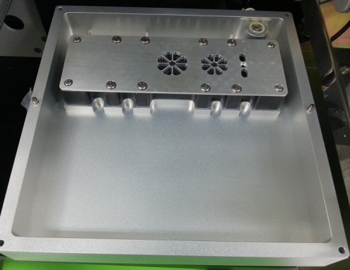
(3) Remove dust deposited inside the dust collecting pad.
  - Cleaning of Dust Collection Tube
- Dust and smoke generated during cutting are discharged outside through the dust collection tube. During the discharge, the inside of the dust collection tube is contaminated. Contact the Service Center every 6 months or once a year (depending on the condition of the tube) to replace the dust collection tube.
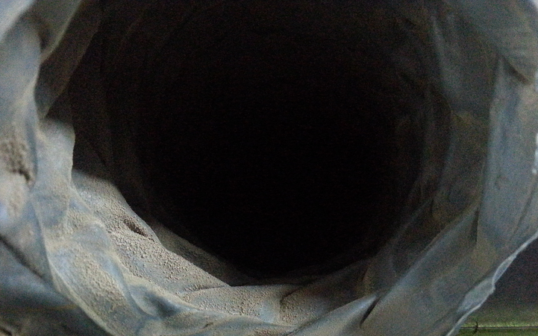
  - Air Filter Maintenance
- As the compressed air is supplied into the system through the air filter, foreign matters and moisture are filtered at the filter. Remove the foreign matters every time the air filter is full.
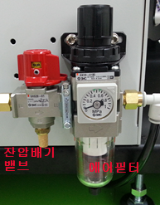
Turn the exhaust valve clockwise to discharge the compressed air from the system inside.
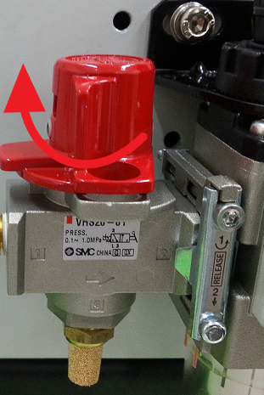
(2) Turn anti-clockwise the cap at the lower part of the air filter, to remove foreign matters and moisture.
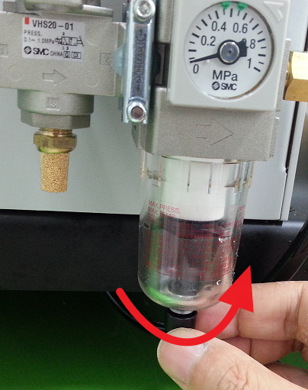
(3) Turn clockwise the lower cap of the air filter to lock.
(4) Turn the exhaust valve anti-clockwise to supply compressed air to the system inside.
(5) The air pressure inside the system should be 0.4 ~0.5MPa.
Pull the upper cap of the air filter upward, turn the cap to the left or right to adjust the air pressure and press down the cap to maintain the air pressure at a constant level.
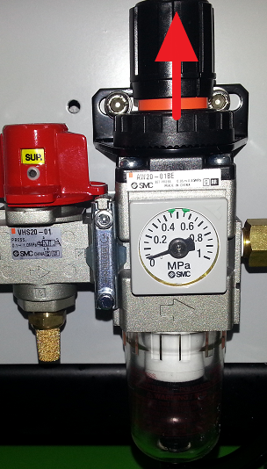
  - Maintenance of Vision Camera and Marksensor
- Use alcohol and cotton to clean the camera lens and the black mark sensor lens periodically.

- Troubleshooting
  - Power not supplied
- Check as follows if there is no power supply to the Product.
(1) Check if the power cable is properly inserted into the power plug.
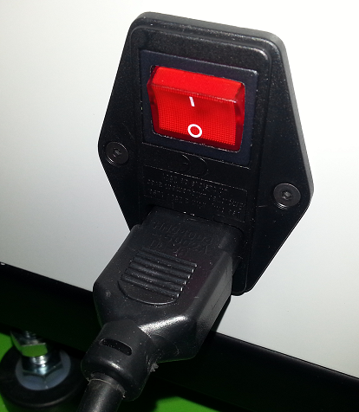
(2) Check if the power fuse is normal.
Step.1 | 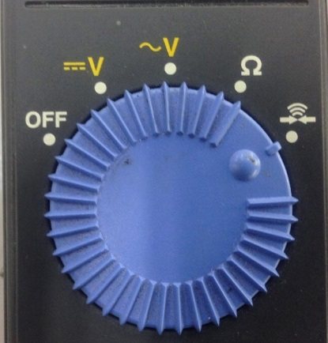 | Position the multi meter controller as shown in the picture.
Step.2 | 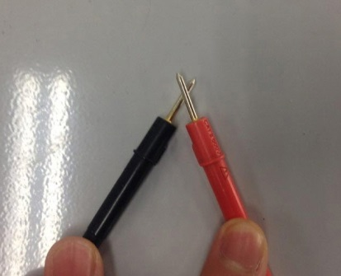 | Get the probes in contact with one another as shown in the picture to see if a ‘beep’ sounds.  (If not, the multi meter is out of order. Use a normal multi meter.)
Step.3 | 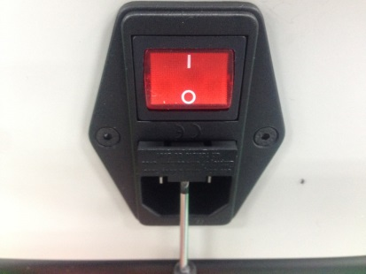 | Use a flat driver to separate the fuse holder as shown in the left picture.
Step.4 | 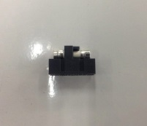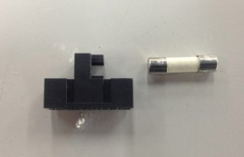 | Remove the fuse from the fuse holder as shown in the picture.
Step.5 | 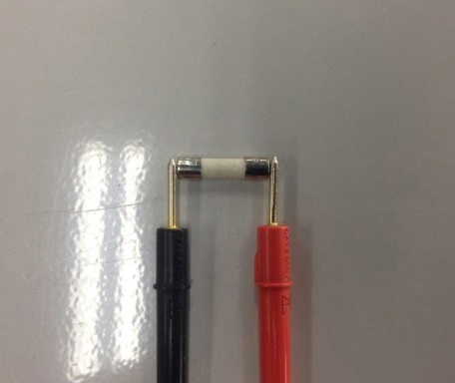 | Get the probes in contact with each side of the fuse.  If a ‘beep’ sounds it is normal. If not replace the fuse. If normal, assemble the fuse with the fuse holder in reverse order.

  - No laser output
(1) Check if the safety door is properly closed.

If the safety door is properly closed, READY LED is illuminated as shown in the above picture.
(2) No laser owing to high temperate on the laser generation device:
Turn power off and wait for about 5 minutes until the temperature is down a bit. Turn power on and wait for about 5 minutes until the temperature is up again, and see if laser is generated.
(3) The connection cable between the laser controller and the laser source is come off:
There are 2 connectors (a p-pin and a 25-pin connector) on the laser controller built inside the PC.
The laser source output is turned ON or OFF through the 9-pin connector. Check if the cable connected hereto is come off.
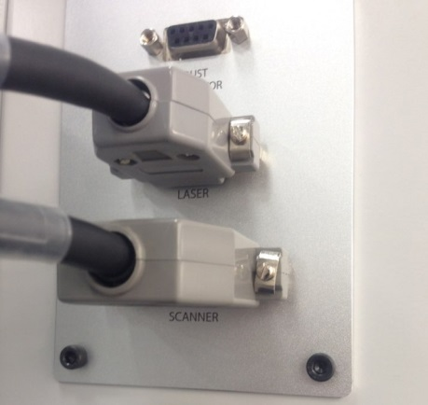  9 Pin  25 Pin | 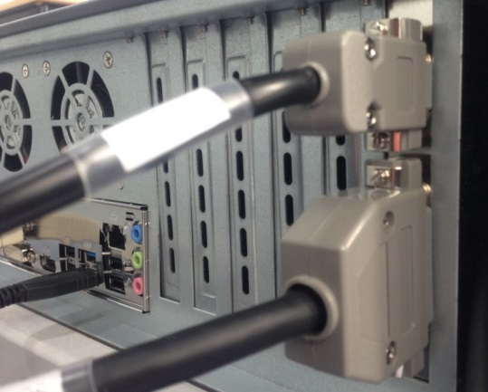
Cable connected to Station | Cable connect to PC

  - No motion with Scanner Head
- Check if the cable is connected to the 25-pin connector on the laser controller of the PC.
Check in the same way as with the picture provided under ‘2-2 No laser output’.
  - No compressed air, No vacuum
(1) Check the compressor gauge to see if compressed air is supplied to the Product.
(2) Check if the air supply valve on the air compressor is shut off.
(3) The exhaust valve must be at the ‘SUP’ position to supply compressed air to the system.
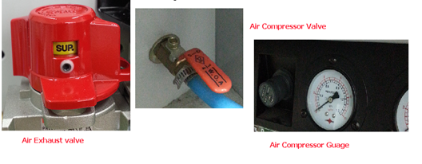
- Replacement Cycle of Parts
- Dust removal brush: yearly
- Vacuum pad cover: yearly
- Dust collector filter: 2-4 times/year

- Equipment Specification
- Weight: 190 Kg
Dimension: 1620(D) x 630(W) X 503(H)
Laser Source: Air Cooled CO2
Laser Output Power: Max 70W
Web Length: 215 mm
Max Web Speed 18M/min

End of Document

